**TRIBHUVAN UNIVERSITY**

**INSTITUTE OF ENGINEERING**

**ADVANCED COLLEGE OF ENGINEERING AND MANAGEMENT**

DEPARTMENT OF ELECTRONICS AND COMPUTER ENGINEERING

KALANKI, KATHMANDU



**A Major Project Progress Defense Report On**

**“Automated Segmentation of Breast Cancer”**

[CT707]

**SUBMITTED BY:**

PRAFUL SAPKOTA [ACE076BCT059]

PRATIK RAJ LAUDARI [ACE076BCT065]

SHRIJAN PANDEY [ACE076BCT082]

A Major Project Progress report submitted to the department of Electronics and Computer Engineering in the partial fulfillment of the requirements for degree of Bachelor of Engineering in Computer Engineering

Kathmandu, Nepal

2nd July 2023

# ACKNOWLEDGEMENT

We would like to take this opportunity to thank our project coordinator, **Er. Laxmi Prasad Bhatt** of the Department of Electronics and Computer Engineering, for his insightful recommendations, inspiring ideas, invaluable guidance, help, and support in the project's initialization, as well as for their ongoing support and advice throughout our Bachelor's program.

We are grateful to **Er. Ajaya Shrestha**, Head of Electronics and Computer Engineering, and **Er. Bikash Acharya, Deputy** Head, for their continued assistance, cooperation, and coordination.

We would like to thank the teaching and non-teaching personnel of the Department of Electronics & Communication and Computer Engineering, ACEM, for their significant assistance and support throughout the Bachelor's Degree program.

We also want to thank all of our classmates for their encouragement, inspiration, and invaluable advice.

Finally, and perhaps most importantly, we want to thank my grandparents, parents, and siblings for their constant support and inspiration throughout the bachelor's degree process.

PRAFUL SAPKOTA [ACE076BCT059]

PRATIK RAJ LAUDARI [ACE076BCT065]

SHRIJAN PANDEY [ACE076BCT082]

# ABSTRACT

Breast cancer is a critical disease affecting women worldwide, requiring early detection and precise diagnosis. Medical imaging, such as mammography and ultrasound, plays a crucial role in breast cancer assessment. However, the complexity and variability of breast tissue make interpretation challenging for healthcare professionals. Artificial intelligence (AI) techniques, particularly image segmentation, have emerged as valuable tools to assist radiologists in identifying and outlining breast cancer regions. This report provides a comprehensive overview of breast cancer image segmentation using AI, including convolutional neural networks (CNN) and U-Net architecture. The report discusses challenges and limitations, such as limited dataset availability, variability in image quality, overfitting, and interpretability of results. The report highlights the wide-ranging applications and benefits of breast cancer image segmentation, including early detection, precise tumor localization, treatment planning, and personalized medicine. Future directions for research and development include integrating multimodal data, transfer learning, explainable AI, and real-time image segmentation for intraoperative applications. In conclusion, AI-based breast cancer image segmentation shows great promise in assisting healthcare professionals, improving patient outcomes, and alleviating the global burden of breast cancer.

Keywords: *Attention Unet, segmentation, breast cancer, ultrasound, mammogram, CNN*

# TABLE OF CONTENTS

ACKNOWLEDGEMENT i

ABSTRACT ii

TABLE OF CONTENTS iii

LIST OF FIGURES v

LIST OF TABLES vi

LIST OF EQUATIONS vii

LIST OF ABBREVRATIONS viii

CHAPTER 1 1

INTRODUCTION 1

1.1 Background 1

1.2 Motivation 2

1.3 Statement of the problem 3

1.4 Project objective 3

1.5 Significance of the study 4

CHAPTER 2 5

LITERATURE REVIEW 5

CHAPTER 3 7

REQUIREMENT ANALYSIS 7

3.1 Project Requirements 7

3.1.1 Hardware requirements 7

3.1.2 Software Requirements 7

3.1.3 Library Used 7

3.2 Functional Requirements 8

3.3 Non-Functional Requirements 9

3.4 Feasibility Study 10

3.4.1 Technical Feasibility 10

3.4.2 Operational Feasibility 10

3.4.3 Economic Feasibility 10

3.4.4 Schedule Feasibility 11

3.4.5 Legal and Ethical Feasibility 11

CHAPTER 4 12

SYSTEM DESIGN AND ARCHITECTURE 12

4.1 Data flow Diagram 12

4.1.1 Data Flow Diagram level 0: 12

4.1.2 Data Flow Diagram level 1: 13

4.2 Use Case Diagram 14

4.3 Class Diagram 15

4.4 Activity Diagram 15

4.5 Sequence Diagram 16

CHAPTER 5 17

METHODOLOGY 17

5.1 Data Collection and Preparation 17

5.2 Model Architecture Selection 17

5.3 Data Preprocessing 19

5.3.1 Image Scaling 19

5.3.2 Image Normalization 20

5.4 Model Training 20

5.5 Model Evaluation and Validation 20

5.6 Post-processing 21

5.7 Analysis 22

5.8 Model Deployment 22

CHAPTER 6 23

EPILOGUE 23

6.1 Work Progress 23

6.1 Work Remaining 26

CHAPTER 7 27

REFERENCES 27

# LIST OF FIGURES

|  |  |  |
| --- | --- | --- |
| **Figure** | **Page No.** | |
| Figure 4.1.1: DFD level 0 | | 12 |
| Figure 4.1.2: DFD level 1 | | 13 |
| Figure 4.2: Use Case Diagram | | 14 |
| Figure 4.3: Class Diagram | | 15 |
| Figure 4.4: Activity Diagram | | 15 |
| Figure 4.5: Sequence Diagram | | 16 |
| Figure 5.1: U-NET Architecture | | 18 |
| Figure 5.2: Attention U-NET Architecture | | 19 |
| Figure 6.1: Index page website | | 23 |
| Figure 6.2: about page website | | 24 |
| Figure 6.3: normalizer | | 24 |
| Figure 6.4: encoder block | | 25 |

# LIST OF TABLES

|  |  |
| --- | --- |
| **Tables** | **Page No.** |
| Table:7.1 Gantt Chart | 24 |

# LIST OF EQUATIONS

|  |  |
| --- | --- |
| **Equations** | **Page No.** |
| Equation 5.1: Dice Coefficient | 21 |
| Equation 5.2: Jaccard Index | 21 |

# LIST OF ABBREVRATIONS

AG Attention Gate

CNN Convolutional Neural Network

SVM Support Vector Machine

AI Artificial Intelligence

ML Machine Learning

FCM-GA Fuzzy C-Means with Genetic Algorithm

ISBI International Society for Biomedical Imaging

JPAN Joint Photographic Experts Group

DCE-MRI Dynamic Contrast-Enhanced Magnetic Resonance Imaging

PACS Picture Archiving and Communication System

HER Human Error Rate

GDPR General Data Protection Regulation

ROI Region of Interest

# CHAPTER 1

# INTRODUCTION

## 1.1 Background

Breast cancer is the most common cancer among women, and early detection is essential for improving survival rates. Breast cancer is the most frequently diagnosed cancer in women worldwide, with 2.26 million [95% UI, 2.24–2.79 million] new cases in 2020 [1]. In the United States, breast cancer alone is expected to account for 29% of all new cancers in women [2].

Mammography is the gold standard for breast cancer screening, but it can be difficult for radiologists to identify small or subtle tumors. Artificial intelligence (AI) can be used to improve the accuracy of breast cancer detection by automatically segmenting tumors in mammograms.

Ultrasound is an imaging technique used for screening, diagnosing, and monitoring breast cancer. It uses sound waves to create detailed images of the breast tissue. Ultrasound can help detect abnormalities, determine the nature of breast lumps, guide biopsies, and monitor treatment response. It is safe, non-invasive, and often used in combination with other tests for a comprehensive evaluation of breast cancer.

Image segmentation is the process of dividing an image into its constituent parts. In the context of breast cancer, image segmentation can be used to identify tumors and other abnormalities in ultrasound. This information can then be used by radiologists to make more accurate diagnoses.

There are a number of different AI techniques that can be used for breast cancer image segmentation. One common approach is to use convolutional neural networks (CNNs). They have been shown to be very effective for a variety of image segmentation tasks, including breast cancer detection.

## 1.2 Motivation

Breast cancer is a significant global health concern, affecting millions of women worldwide and causing substantial morbidity and mortality. Early detection is essential for successful treatment outcomes, as it allows for timely intervention and improved survival rates. Medical imaging, particularly mammography, is widely used for breast cancer screening and diagnosis, but the interpretation of mammograms can be challenging due to the complexity and variability of breast tissue. Artificial Intelligence (AI), specifically image segmentation, has emerged as a promising solution to address the challenges associated with breast cancer diagnosis. AI algorithms can automatically analyze medical images and identify regions of interest, including cancerous areas, with remarkable accuracy.

Image segmentation using AI not only helps in identifying potential abnormalities but also aids in quantifying tumor size, shape, and spatial extent, which are crucial for treatment planning and monitoring. The integration of AI in breast cancer image segmentation has the potential to enhance the workflow in radiology departments, reduce interpretation time, and facilitate a more standardized approach to diagnosis. The automation and standardization offered by AI-based segmentation methods can help mitigate inter-observer variability and improve overall diagnostic accuracy, thereby leading to better patient care and outcomes.

## 

## 1.3 Statement of the problem

The statement of the problem revolves around the need for improved and standardized methods for breast cancer image segmentation using AI. The complexity and variability of breast tissue, coupled with the subjective interpretation of ultrasound, can lead to variations in diagnosis and treatment decisions. Manual segmentation of breast cancer regions in medical images is a time-intensive and laborious task for radiologists, and automating the segmentation process using AI techniques can help save time and reduce the burden on healthcare professionals. Additionally, there is a lack of standardized tools and techniques for breast cancer image segmentation using AI. Addressing these problems is crucial to enhancing the accuracy, efficiency, and standardization of breast cancer diagnosis and treatment. By developing robust AI-based segmentation methods, it becomes possible to improve the detection and localization of breast cancer regions, reduce inter-observer variability, and provide healthcare professionals with reliable tools for more accurate and efficient decision-making.

## 1.4 Project objective

The major objective of this project is to develop AI based segmentation model for breast cancer and other objectives are:

* To improve accuracy and efficiency in breast cancer diagnosis.
* To reduce inter-observer variability and improve standardization.
* To automate and expedite the process of breast cancer image segmentation.
* To investigate the potential for personalized treatment planning.
* To investigate the impact of AI on clinical workflow and decision-making in breast cancer.

## 1.5 Significance of the study

The significance of the study are listed below:

* **Improved accuracy of diagnosis**: AI-based segmentation models can accurately identify breast cancer regions, which can significantly improve the accuracy of diagnosis. This can lead to timely interventions, improved treatment planning, and ultimately better patient outcomes.
* **Reduced inter-observer variability:** Automating the segmentation process can help to lower inter-observer variability in breast cancer diagnosis. This is because the segmentation approach would be standardized and repeatable across different radiologists and healthcare facilities. This would increase confidence in the correctness of the results and diagnostic consistency.
* **Reduced workload for radiologists:** Automating breast cancer image segmentation can significantly reduce the workload for radiologists. This is because the segmentation process can be shortened, which would enable quicker diagnosis and timely intervention and treatment planning. This increase in productivity can enhance patient management and maximize resource use.
* **Detailed information about tumor characteristics:** Accurate segmentation of breast cancer regions can provide detailed information about tumor characteristics, such as size, shape, and spatial extent. This personalized approach has the potential to lead to improved treatment outcomes and patient satisfaction.
* **Revolutionized breast cancer diagnosis and treatment:** By leveraging AI-based segmentation models, this study has the potential to revolutionize breast cancer diagnosis and treatment. It can improve diagnostic accuracy, reduce variability, expedite the segmentation process, enable personalized treatment planning, enhance clinical workflow, and contribute to the advancement of medical practice in the field of breast cancer care.

# CHAPTER 2

# LITERATURE REVIEW

Breast cancer remains a significant global health concern, affecting millions of women worldwide and causing substantial morbidity and mortality. Early detection plays a pivotal role in improving treatment outcomes and survival rates. However, the interpretation of mammograms, the gold standard for breast cancer screening, can be challenging due to the complexity and variability of breast tissue.

In paper titled "Breast Cancer Segmentation Methods: Current Status and Future Potentials" provides an analysis of the current status and future potential of breast cancer detection and diagnosis using segmentation models. The paper discusses the challenges in breast cancer segmentation and the various methods used to address them, including the FCM-GA algorithm and the Unet3+ deep learning framework. The paper also describes multiclass semantic segmentation of breast cancer images into different classes, such as tumour, stroma, and inflammatory. Finally, the paper highlights the importance of deep learning-based automatic segmentation for size and volumetric measurement of breast cancer on magnetic resonance imaging. [3].

This paper titled "U-Net: Convolutional Networks for Biomedical Image Segmentation" (Olaf Ronneberger, Philipp Fischer, and Thomas Brox) provide a network and training technique that depends on data augmentation to make better use of the available labeled samples. The research suggests a fast and accurate method for segmenting biomedical images using convolutional neural networks called U-Net. On the ISBI challenge for segmentation of neural structures in electron microscopic stacks, the authors demonstrate that such a network can be trained end-to-end from a small number of photos and exceeds the previous best solution (a sliding-window convolutional network). The network can also be used to solve several biomedical segmentation issues. In order to separate contacting items belonging to the same class. [4].

The paper proposes a joint-phase attention network (JPAN) for breast cancer segmentation in dynamic contrast-enhanced magnetic resonance imaging (DCE-MRI). The JPAN model combines the advantages of both the spatial attention and temporal attention mechanisms to learn the spatial and temporal features of breast cancer tumors. The paper evaluated the JPAN model on a dataset of 272 patients. The results showed that the JPAN model achieved a Dice coefficient of 72%, which was significantly higher than the baseline models. The paper concludes that the JPAN model is a promising approach for breast cancer segmentation in DCE-MRI. The model is able to learn the spatial and temporal features of breast cancer tumors, which leads to improved segmentation performance[5].

The paper "A Novel Approach for Breast Cancer Detection and Segmentation in a Mammogram" by Amiri et al. (2015) proposes a new method for breast cancer detection and segmentation in mammograms. The method uses a combination of wavelet transform and morphological operations to extract features from the mammograms and train a support vector machine (SVM) classifier to detect and segment the tumors. The main contributions of the paper are the use of wavelet transform to extract features from mammograms, the use of morphological operations to improve the accuracy of the features, and the use of an SVM classifier to detect and segment tumors. The paper also discusses the limitations of the method, such as the need for a large dataset for training the classifier, but the authors believe that the method is a promising approach for breast cancer detection and segmentation.[6]

The paper “Attention U-Net: Learning Where to Look for the Pancreas” by Ozan Oktay and team proposes a novel attention gate (AG) model for medical imaging that automatically learns to focus on target structures of varying shapes and sizes. Models trained with AGs implicitly learn to suppress irrelevant regions in an input image while highlighting salient features useful for a specific task. This enables the elimination of the necessity of using explicit external tissue/organ localization modules of cascaded convolutional neural networks (CNNs). AGs can be easily integrated into standard CNN architectures such as the U-Net model with minimal computational overhead while increasing the model sensitivity and prediction accuracy. The proposed Attention U-Net architecture is evaluated on two large CT abdominal datasets for multi-class image segmentation. Experimental results show that AGs consistently improve the prediction performance of U-Net across different datasets and training sizes while preserving computational efficiency. The source code for the proposed architecture is publicly available.[7]

# 

# CHAPTER 3

# REQUIREMENT ANALYSIS

## 3.1 Project Requirements

### 3.1.1 Hardware requirements

* Processor: Intel Core i5 or higher
* Speed: 2.3 GHz
* RAM: 8GB
* Hard disk: 40 GB and above

### 3.1.2 Software Requirements

* Operating System: Linux/Windows/MacOS
* Programming Language: Python v3.11.0
* IDE: VS code/Jupyter Notebook

### 3.1.3 Library Used

* keras: used for developing and training neural network models
* numpy: used for scientific computing and data manipulation
* pandas: used for data manipulation, analysis, and preparation
* tensorflow: designed to efficiently build, train, and deploy machine learning models, particularly neural networks
* matplotlib: creating static, animated, and interactive visualizations

## 3.2 Functional Requirements

The functional requirements describe the core functionality of the model. The functional

requirements essentially describe what are expected from a system. They specify the

task and functionalities of the system. These are collected from users based on user

requirements. These are collected from clients as functional requirements document and

developers work to implement all the features. The project functional requirements

are as follows:

* Preprocess the images to improve quality and accuracy.
* Allow user or automated ROI selection.
* Utilize advanced segmentation algorithms to identify cancerous regions.
* Support segmentation from different imaging modalities.
* Provide visual feedback by overlaying segmented regions on the original image.
* Offer post-segmentation analysis tools for quantification and evaluation.
* Integrate with clinical systems like PACS or EHR.
* Handle large datasets efficiently and scale to accommodate increasing data volumes.
* Have an intuitive user interface for easy interaction.
* Undergo validation and testing for accuracy and reliability.

## 

## 3.3 Non-Functional Requirements

Non-functional requirements are those requirements of the system which are not directly concerned with specific functionality delivered by the system. These are mainly concerned with the functionalities that are not mentioned as the core functionalities of project. They may be related to emergent properties such as reliability, usability etc.

* Accuracy: Achieve high segmentation accuracy.
* Robustness: Handle variations in image quality and different imaging modalities.
* Speed and Efficiency: Perform segmentation quickly and efficiently.
* Scalability: Handle large volumes of images without performance degradation.
* Resource Requirements: Optimize resource usage (computational power, memory, storage).
* Flexibility and Adaptability: Adapt to different imaging modalities and incorporate new techniques.
* User Experience: Provide a user-friendly interface for easy interaction.
* Reliability: Minimize errors, crashes, and ensure stability.
* Interoperability: Integrate with other clinical systems and support data exchange.
* Security and Privacy: Protect patient data and comply with privacy regulations.
* Regulatory Compliance: Adhere to relevant healthcare regulations and standards.
* Documentation and Support: Provide comprehensive documentation and technical support.

## 3.4 Feasibility Study

### 3.4.1 Technical Feasibility

The breast image segmentation project using the Attention U-Net architecture demonstrates favorable feasibility across multiple aspects. From a technical perspective, the Attention U-Net architecture has proven effective in various image segmentation tasks, indicating its suitability for breast image segmentation. The required technologies, such as deep learning frameworks and image processing libraries, are widely available, making implementation technically feasible. Adequate computational resources, including hardware with high-performance GPUs, should be in place to handle the training and inference processes efficiently.

### 3.4.2 Operational Feasibility

Operational feasibility requires the availability of skilled personnel, including data scientists, machine learning engineers, and medical imaging domain experts. Adequate expertise in deep learning, image processing, and medical imaging is necessary to develop and implement the Attention U-Net model effectively. Collaboration with medical professionals and experts is essential for dataset annotation, evaluation of results, and clinical validation, ensuring the project's operational success.

### 3.4.3 Economic Feasibility

Economically, the project's feasibility is promising. While there may be costs associated with acquiring computing resources, software licenses, and obtaining the necessary dataset, the prevalence of open-source deep learning frameworks and libraries significantly reduces the economic burden. Furthermore, the availability of existing datasets or collaborations with medical institutions may alleviate the dataset procurement cost.

### 3.4.4 Schedule Feasibility

The project's schedule feasibility depends on factors such as dataset size and complexity, model training and validation duration, and the availability of skilled personnel. Allocating sufficient time for data collection, preprocessing, model training, validation, and testing is essential to ensure accurate and reliable results. Iterations and refinements in model design and hyperparameter tuning should also be considered, impacting the project's schedule.

### 3.4.5 Legal and Ethical Feasibility

Legal and ethical feasibility play vital roles in the project. Compliance with regulations, such as patient privacy and data protection laws like GDPR, is crucial. Consent and approval should be obtained for the use of medical image datasets, ensuring proper anonymization and secure handling of patient data to protect confidentiality. Adhering to legal and ethical considerations enhances the feasibility and integrity of the project.

# CHAPTER 4

# SYSTEM DESIGN AND ARCHITECTURE

Images are collected and preprocess is done, which is ultrasound images of breast cancer tumors. The images need to be resized and normalized before they can be used to train the model. The next step is to choose a model for image segmentation. The Attention UNet model is a good choice for this project because it is able to learn complex features from the images. The model is then trained on a large dataset of images. The training process can be time-consuming, but it is important to train the model on a large dataset to achieve good results. Once the model is trained, it needs to be deployed in a production environment. The model can be deployed on a cloud server or on a local machine. The project uses Python as the programming language and PyTorch as the framework.

## 4.1 Data flow Diagram

### 4.1.1 Data Flow Diagram level 0:

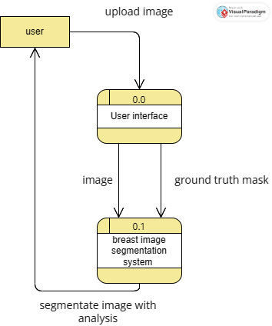

Figure 4.1.1: dataflow diagram level 0

### 4.1.2 Data Flow Diagram level 1:

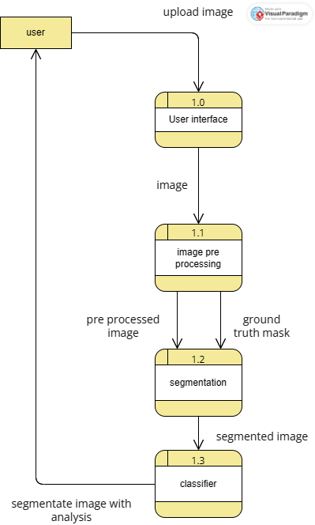

Figure 4.1.2: dataflow diagram level 1

## 4.2 Use Case Diagram

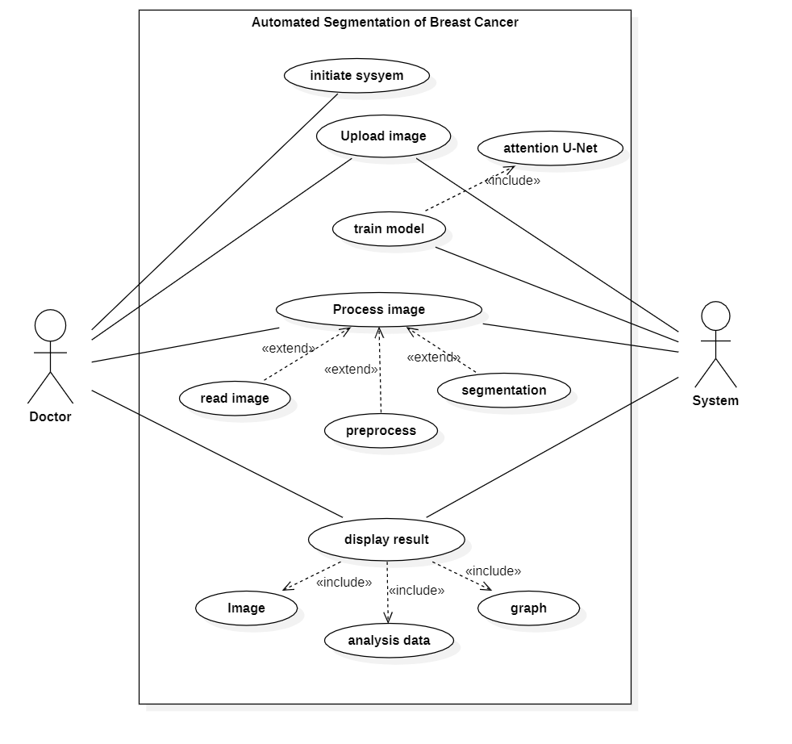

Figure 4.2: Usecase diagram

## 4.3 Class Diagram

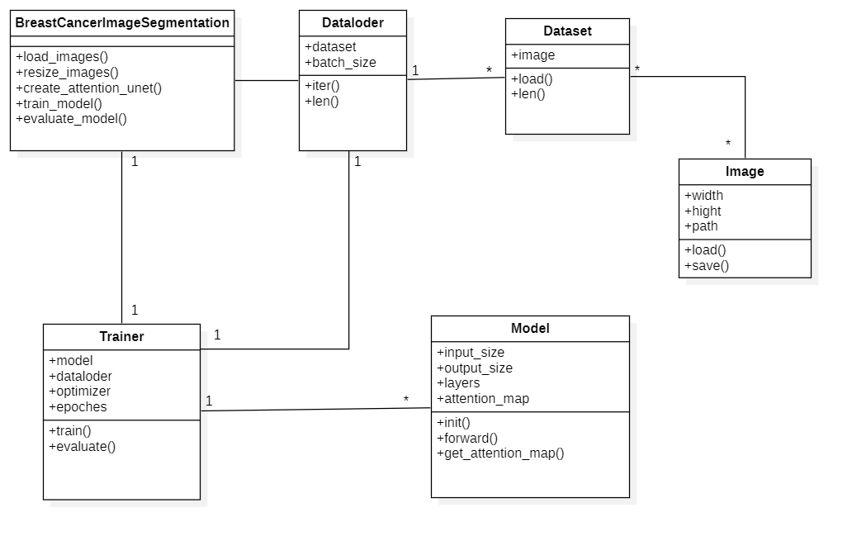

Figure 4.3: Class diagram

## 4.4 Activity Diagram

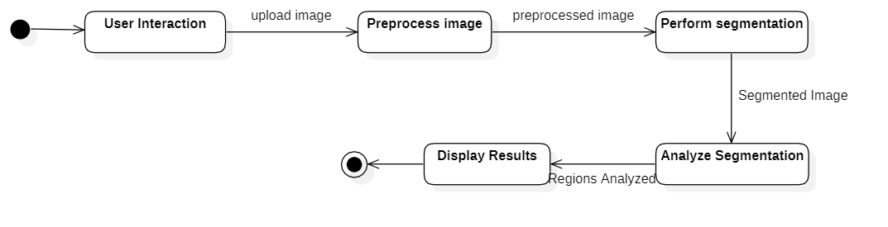

Figure 4.4: Activity diagram

## 4.5 Sequence Diagram

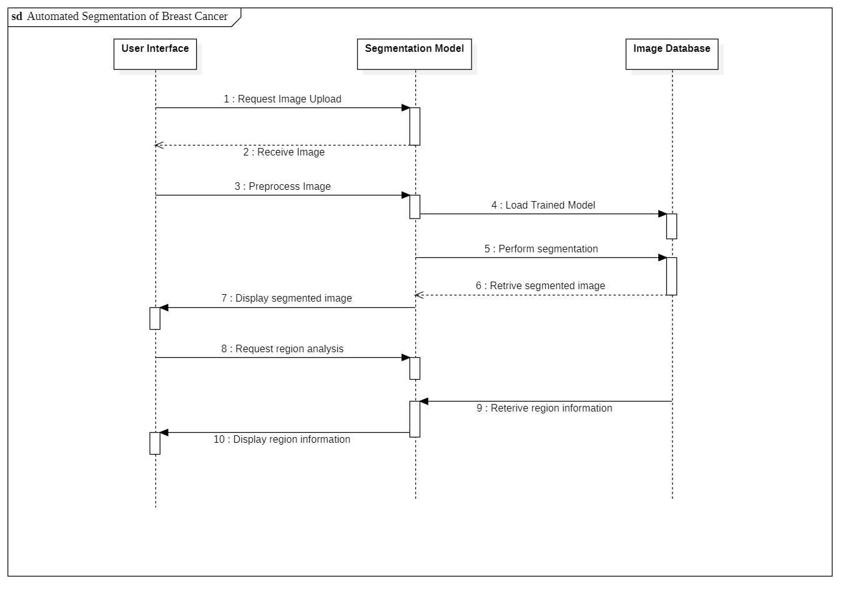

Figure 4.5: Sequence diagram

# CHAPTER 5

# METHODOLOGY

Breast cancer segmentation is a fundamental component of an effective breast cancer diagnosis system. This project's goal is to learn how to work with medical images in Python, calculate image features from them, apply machine learning algorithms to them, and evaluate the results. The major objective is to develop a machine learning model that can segment breast cancer tumors from medical images in a more systematic way. It uses a medical image as its input and seeks to identify the tumor region. Making the diagnosis of breast cancer easier and quicker is the goal of automating breast cancer segmentation. This takes a lot of time and is challenging. Automating breast cancer segmentation can make it easier to locate important information like the size and location of tumors, which can help doctors make more accurate diagnoses.

## 5.1 Data Collection and Preparation

The data collection is the initial step for our project. We are going to use ultrasound images in PNG format. The data set contains the images with malignant and benign tumors located in the different section of breast.

## 5.2 Model Architecture Selection

The Attention U-Net architecture is a suitable choice for breast image segmentation. It combines the U-Net architecture, which leverages both contracting and expanding pathways, with attention mechanisms to focus on relevant image features during segmentation. Understanding the structure and components of the Attention U-Net model, including the encoder, decoder, and attention modules, is important for effective implementation.

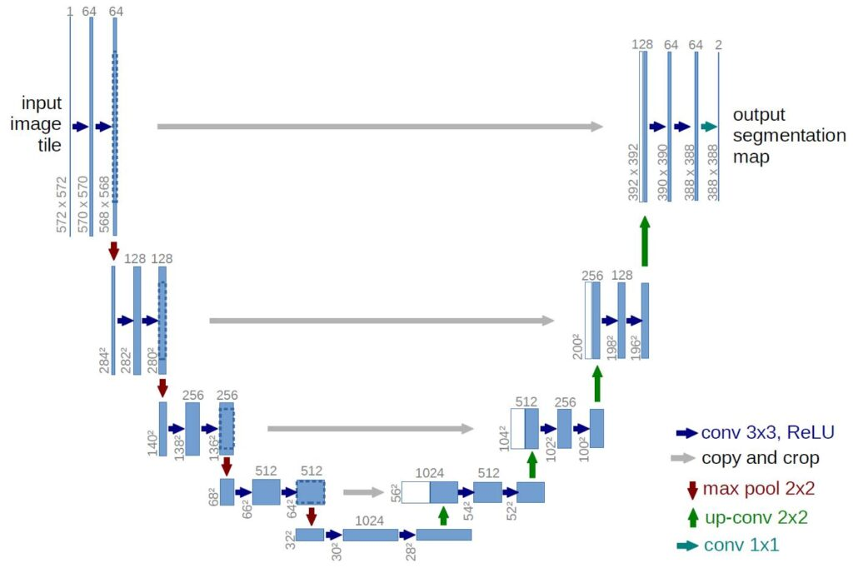

Figure 5.1: Unet Architecture

*source:idiotdeveloper.com/attention-unet-and-its-implementation-in-tensorflow/*

UNET is an architecture developed by Olaf Ronneberger et al. for Biomedical Image Segmentation in 2015 at the University of Freiburg, Germany. It is one of the most popularly used approaches in any semantic segmentation task today. UNET is a U-shaped encoder-decoder network architecture consisting of four encoder blocks and four decoder blocks connected via a bridge. The encoder network (contracting path) has half the spatial dimensions and double the number of filters (feature channels) at each encoder block. Likewise, the decoder network doubles the spatial dimensions and half the number of feature channels.

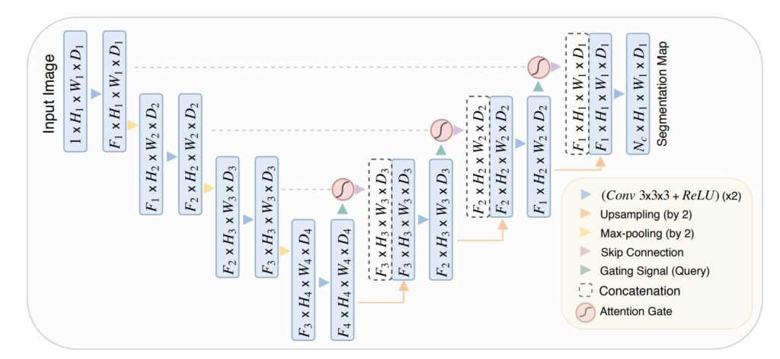

Figure 5.2: Attention unet architecture

*source:idiotdeveloper.com/attention-unet-and-its-implementation-in-tensorflow/*

Attention UNET is a type of Convolutional Neural Network (CNN) that is commonly used for image segmentation tasks. It is an extension of the original U-Net architecture, which was proposed for biomedical image segmentation. Attention UNET combines the UNET with the novel Attention Gate which helps the network focus on relevant regions and boost performance.

Attention UNET is an encoder-decoder style of architecture that combines the strengths of the UNET and the proposed Attention Gate. The key innovation of Attention U-Net is the incorporation of an attention mechanism, which helps the network focus on relevant regions of the input image while filtering out noise and irrelevant information.

## 5.3 Data Preprocessing

The data pre-processing involves two main steps. They are image scaling and image normalization.

### 5.3.1 Image Scaling

The technique of altering an image's size is known as image scaling. It provide Standardization to input image. The standardization of image size in a dataset is done for machine learning data training. This is significant because it enables the model to train on images of uniform size, which can increase accuracy. The amount of memory needed to hold the dataset can also be decreased by resizing the images.

### 5.3.2 Image Normalization

Image normalization is a crucial step in machine learning, transforming image data to have a standard distribution, ensuring the mean and standard deviation of pixel values remain consistent for all images in the dataset. This process improves the performance of machine learning models by speeding up the training process, making the data more consistent, and preventing overfitting. Normalization helps to make the data more spread out, making it harder for the model to memorize the training data. In the breast cancer image segmentation project, image normalization is performed by calculating the mean and standard deviation of the entire dataset, then normalizing each pixel by subtracting the mean and dividing by the standard deviation.

## 5.4 Model Training

For model training we first will import the images with its binary ground truth mask. The model is trained for certain number of epochs depending upon the requirement and improving accuracy of the project. The training is done by Unet architecture which consist of encoder and decoder.

The encoder component of the U-Net model is in the role of extracting features from images. The encoder is made up of convolutional layers followed by max pooling layers. The max pooling layers lower the size of the image while simultaneously preserving the image's essential components.

The decoder component of the U-Net model is in charge of recreating images from the encoder's extracted features. The decoder is made up of convolutional layers followed by upsampling layers. The upsampling layers enhance the image size while simultaneously preserving the spatial data contained in the image.

## 5.5 Model Evaluation and Validation

The trained model's performance needs to be evaluated using the validation set, which consists of images that were not used during training. The segmentation results produced by the model are compared against the ground truth masks using metrics such as the Dice coefficient, Jaccard index,. This evaluation helps assess the model's ability to accurately segment breast regions and detect tumors. Fine-tuning the model based on the validation results may be necessary to improve its performance.

The formula for dice coefficient and Jaccard index is given by:

dice_coefficient = 2 * (intersection / (area_of_prediction + area_of_ground_truth))

equation 5.1: Dice Coefficient

jaccard_index = intersection / (intersection + union)

equation 5.2: Jaccard Index

where,

Intersection is the area of overlap between the model's predictions and the ground truth masks.

Union is the total area of the model's predictions and the ground truth masks.

## 5.6 Post-processing

The post processing is done to improve the quality of segmented image. The post processing that can be done are morphological operation and thresholding.

Morphological operations are image processing techniques that deal with the form of image features. They can be used to remove noise from images, smooth edges, and link or separate objects. Dilation and erosion are two of the most common morphological procedures.

• Dilation increases the size of objects in an image by adding pixels to their edges. This can be used to fill up small gaps or to unite disparate objects.

• Erosion reduces the size of objects in an image by eliminating pixels from their borders. This can be used to reduce background noise or to isolate items from their surroundings.

Thresholding procedures are a group of techniques that turn an image into a binary image by assigning a value of 0 or 1 to each pixel. This can be achieved by defining a threshold value and then assigning a value of 1 to all pixels with values more than or equal to the threshold and a value of 0 to all pixels with values less than the threshold.

## 5.7 Analysis

For analysis we can use the provided information and classify the type of tumour. There are mainly two classification benign(uncancerous) and malignant(cancerous). This can be achieved by using different architecture like SVM or CNN.

## 5.8 Model Deployment

Our goal with this project is to provide essential screening methods in a short amount of time, which requires accessibility, so we would like to create a simple web app for deployment that receives ultrasound image input from the user and then provides the user with an image showing the ROI map of the tumor if identified in the provided image.

# CHAPTER 6

# EPILOGUE

We have divided the project in to three main categories: Web app, Attention Unet architecture, CNN classifier.

The web app is the User interface where user can upload the ultra sound picture and upload it to get the segmented result and the classification of tumor. Its frontend is made up of html, CSS and java script, and the back-end data will bill handled with Django.

Attention Unet architecture then consist of data normalization, encoder block, decoder block, attention function.

CNN classifier is used for classification of the type of breast cancer.

## 6.1 Work Progress

The work that we have completed are:

Dataset collection: For the completion of this project, we have collected breast image ultrasound with their ground truth mask/s which can be used for both segmentation and classification input.

Web app: In web app we have developed a simple website which can take input image file from the user.

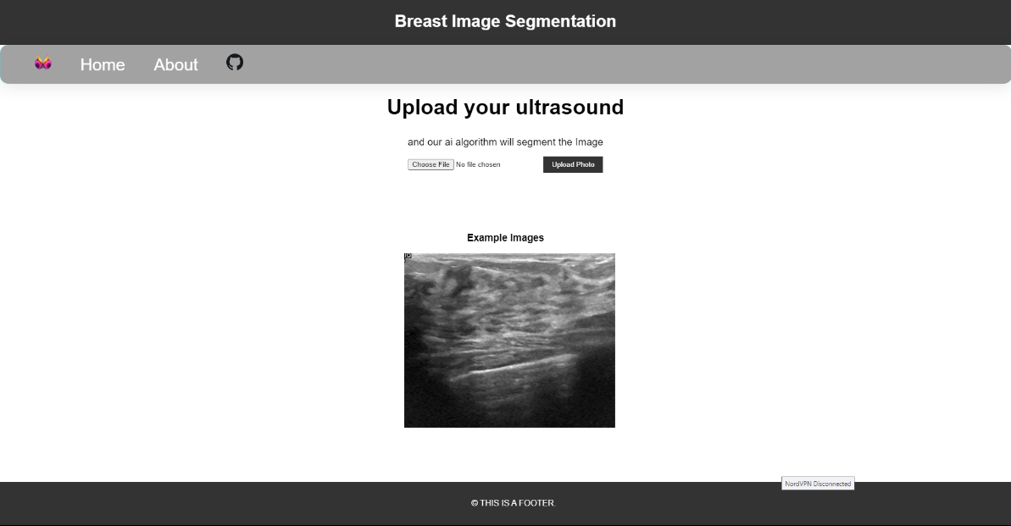

Fig 6.1: Index page of website



Fig 6.2: About page website

Similarly, for Unet architecture we have started data normalization and encoder block’s programing.

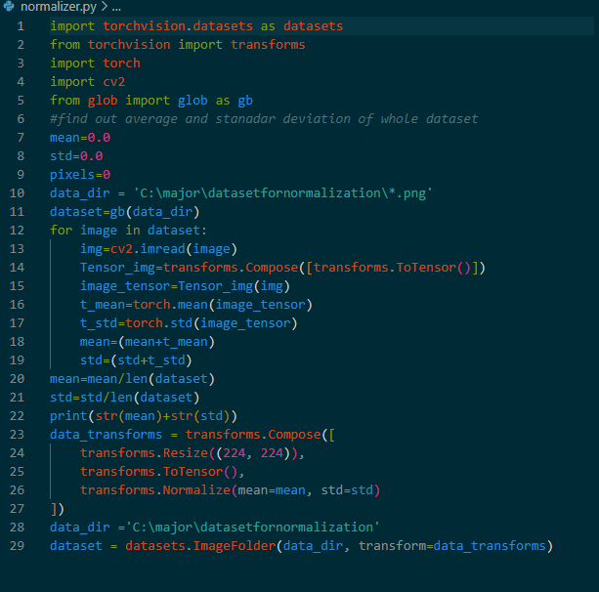

Fig 6.3 normalizer

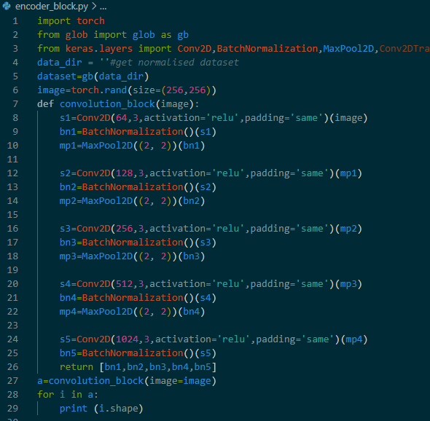

Fig: encoder block

## 6.1 Work Remaining

The list of work that are remaining are:

* Web app back-end
* Decoder block
* Attention function
* CNN classifier
* Testing and improvement
* Deployment

# CHAPTER 7

# REFERENCES

1. World Health Organization . *Global Health Estimates 2016: Disease Burden by Cause, Age, Sex, by Country and by Region, 2000–2016.* World Health Organization; Geneva, Switzerland: 2018.
2. Ferlay J., Ervik M., Lam F., Colombet M., Mery L., Piñeros M., Znaor A., Soerjomataram I., Bray F. *Global Cancer Obser-Vatory: Cancer Today.* International Agency for Research on Cancer; Lyon, France: 2020.
3. E. Michael, H. Ma, H. Li, F. Kulwa, and J. Li, “Breast cancer segmentation methods: Current status and future potentials,” *BioMed Research International*, vol. 2021, pp. 1–29, 2021. doi:10.1155/2021/9962109
4. O. Ronneberger, P. Fischer, and T. Brox, “U-Net: Convolutional Networks for Biomedical Image Segmentation,” *Lecture Notes in Computer Science*, pp. 234–241, 2015. doi:10.1007/978-3-319-24574-4_28
5. R. Huang *et al.*, “Joint-phase attention network for breast cancer segmentation in DCE-MRI,” *Expert Systems with Applications*, vol. 224, p. 119962, 2023. doi:10.1016/j.eswa.2023.119962
6. A.K. Singh and B. Gupta, “A Novel Approach for Breast Cancer Detection and Segmentation in a Mammogram,” Procedia Computer Science, vol. 54, pp. 676–682, Jan. 2015, doi: <https://doi.org/10.1016/j.procs.2015.06.079>.
7. Oktay, O., Schlemper, J., Le Folgoc, L., Lee, M., Heinrich, M., Misawa, K., Mori, K., McDonagh, S., Hammerla, N. Y., Kainz, B., Glocker, B., & Rueckert, D. (2018). “Attention U-Net: Learning where to look for the pancreas.” *arXiv preprint arXiv:1804.03999*